Problem Set 5 – Multiple Regression Part II

Problem 1 (25 points)
Please access the Real Estate Data dataset. These data are from Kaggle, and no license agreement was listed as known. Latitude, longitude pairs within the data suggest they correspond to housing prices in New Taipei City, in the Xindian District, Taiwan. This led to certain assumptions being made about the units for the variables. The dataset consists of:
- Age of House (years)
- Distance to Nearest MRT Station (meters)
- Number of Convenience Stores (within a kilometer)
- Latitude
- Longitude
- House Price Per Unit Area (Taiwanese dollars)
Use JMP to regress House Price Per Unit Area on the other five variables. Do not use any transformations. Please answer each of the following questions. So that your answers remain focused, you are to include ONLY the item(s) requested (else, your earned credit will be reduced).
- (5 points) The Analysis of Variance table offers a single F test. That F test is shown below.
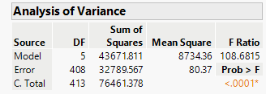
Identify the hypothesis this F is testing. Only one of the possible answers shown below is reasonable. Place an “X” in the box to the immediate left of your chosen answer.
Problem 1a: Solution Choices
 | H0: β₁=β₂=β₃=β₄=β₅, where the β_{j}’s are the slope coefficients of the five regressor variables.
 | H0: α=β₁=β₂=β₃=β₄=β₅=0, where the β_{j}’s are the slope coefficients of the five regressor variables, and α is the intercept.
X | H0: β₁=β₂=β₃=β₄=β₅=0, where the β_{j}’s are the slope coefficients of the five regressor variables.
 | H0: β_{j}=0, for at least one slope coefficient, β_{j}.
- (5 points) The Analysis of Variance table offers a single F test. That F test is shown below.
State what you can conclude from the results of this test, in context. Only one of the possible answers shown below is reasonable. Place an “X” in the box to the immediate left of your chosen answer.
Problem 1b Solution Choices
X | There is evidence that at least one of the five regressors has a non-zero slope coefficient within the linear model specified.
 | There is evidence that at least one of the five regressors has a zero slope coefficient within the linear model specified.
 | There is evidence that all five regressors have non-zero slope coefficients within the linear model specified.
 | There is evidence that all five regressors have zero slope coefficients within the linear model specified.

- (5 points) The Parameter Estimates table is shown below.
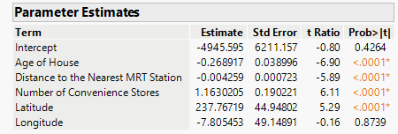
Assess the statistical significance of the five regressors, using only the information in that table. Only one of the possible answers shown below is reasonable. Place an “X” in the box to the immediate left of your chosen answer.

Problem 1c: Solution Choices
 | The overall F test from part a. already confirms (with a small p-value) that all of the regressors are statistically important in the model.
X | All the regressors except Longitude have p-values that are smaller than 0.05, so are assessed as statistically significant in the presence of the other regressors.
 | Only Longitude has a p-value bigger than 0.05, so Longitude is assessed as statistically significant in the presence of the other regressors.
 | The estimated slope of Distance to Nearest MRT Station is (in absolute value) less than 0.05, so it is the only one failing to rise to the level of statistical significance.

- (5 points) Use JMP to construct a fully labeled plot of Distance to Nearest MRT Station vs. Longitude. Paste that plot here.
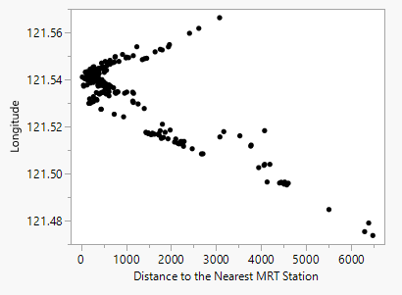

- (5 points) In three sentences or less, explain why what you see in this plot might account for Longitude not showing up as important in the full model.

Longitude and distance to nearest MRT Station are strongly related, meaning they contain overlapping information and form a somewhat unique pattern. Because MRT Distance is already included in the full model, longitude provides little additional information for explaining house prices.

Problem 2 (25 points)
Please access the Possum dataset. The dataset was taken from a Kaggle posting with documentation stating that “the possum data frame consists of nine morphometric measurements on each of 104 mountain brushtail possums, trapped at seven sites from Southern Victoria to central Queensland.” The original publication is listed as: Lindenmayer, et al., 1995. Australian Journal of Zoology 43: 449-458.
For this problem we are only interested in the following variables. Units are suppressed since they are not clearly stated in the Kaggle posting:
- hdlength (head length)
- skullw (skull width)
- totlngth (total length)
- footlgth (foot length)
- earconch (ear conch length mm)
- eye (eye diameter)
- chest (chest breadth)
- belly (belly breadth)
Take totlngth as your response variable and use the other seven variables as regressors. Please fit the full model with no transformations, and answer each of the following questions. So that your answers remain focused, you are to include ONLY the output or answers that are requested (else, your earned credit will be reduced).
  - (5 points) In three sentences or less, explain how you would decide if a transformation of the regressor skullw was warranted. Don’t do any transformations or run any models.

I would create a scatterplot of total length versus skull width and examine the relationships for nonlinearity. If the relationship shows substantial curvature rather than an approximately linear pattern, a transformation of skull width may be warranted

  - (3 points) Copy and paste the Parameter Estimates Table in the space below.

Term | Estimate | Std Error | t Ratio | Prob>|t|
Intercept | 12.649262 | 8.657831 | 1.46 | 0.1473
hdlngth | 0.5206792 | 0.1371 | 3.80 | 0.0003*
skullw | -0.021797 | 0.14706 | -0.15 | 0.8825
footlgth | 0.3466441 | 0.130145 | 2.66 | 0.0091*
earconch | -0.222343 | 0.129665 | -1.71 | 0.0897
eye | 0.120998 | 0.312625 | 0.39 | 0.6996
chest | 0.287011 | 0.225357 | 1.27 | 0.2059
belly | 0.1502679 | 0.142683 | 1.05 | 0.2949

  - (7 points) Refer to part b. For each of the seven regressors, briefly identify whether the regressor was statistically significant and how you know that.
hdlngth: Statistically significant because p = 0.0003 < 0.05.
skullw: Not statistically significant because p = 0.8825 > 0.05.
footlgth: Statistically significant because p = 0.0091 < 0.05.
earconch: Not statistically significant because p = 0.0897 > 0.05.
eye: Not statistically significant because p = 0.6996 > 0.05.
chest: Not statistically significant because p = 0.2059 > 0.05.
belly: Not statistically significant because p = 0.2949 > 0.05.

  - (2 points) From output for the full model fit, fill in the following information.

Full Model
Model Sums of Squares | Error Sums of Squares
1048.1 | 848.85

  - (2 points) Fit the model again but without hdlength and footlgth. Fill in the following information.

Reduced Model
Model Sums of Squares | Error Sums of Squares
814.047 | 1082.9

  - (6 points) Use the information from parts d. and e. to test the following hypothesis, with a conclusion stated in the context of the full seven-regressor model. Show all your steps and present your answer as a series of bullet points.

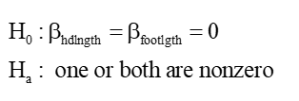

- Full-model SSE = 848.8483 and reduced-model SSE = 1082.9008.
- The number of restrictions is q = 2, and the full-model error degrees of freedom is 95.
- Calculate the Partial F stat
((1082.92 – 848.84)/2)/(848.84/95) = 13.10
- The P-value for F(2, 95) = 13.10 is < 0.0001
- Reject the null hypothesis: There is significant evidence that head length and/or foot length have nonzero slope coefficients in the full seven-regressor model for predicting total length.

